**Press Release**

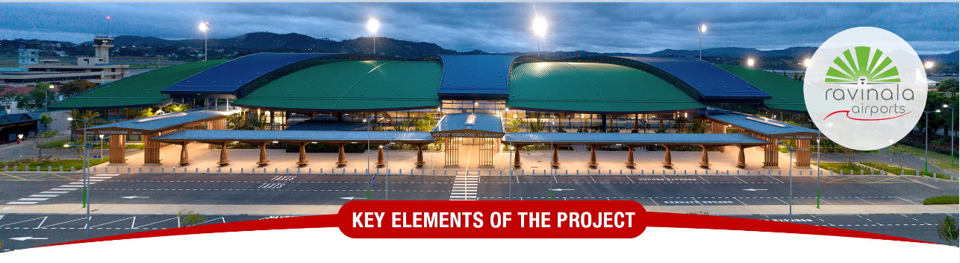

**The international airports of Antananarivo and Nosy Be among the Top 10 in Africa to achieve Level 3 Airport Carbon Accreditation (ACA)**

**Antananarivo, June 17, 2025**

Ravinala Airports is pleased to announce that the international airports of Antananarivo and Nosy Be have been awarded Level 3 Airport Carbon Accreditation (ACA) by Airports Council International (ACI). This international recognition highlights the ongoing efforts led by Ravinala Airports and the airport community to reduce CO₂ emissions at both airports and to transition toward sustainable airport management.

After successfully achieving Levels 1 and 2 of the Airport Carbon Accreditation, this new milestone—known as “Optimization”—demonstrates Ravinala Airports’ concrete commitment not only to measuring and reducing their carbon footprint, but also to engaging all stakeholders (airlines, service providers, authorities, etc.) in a collective approach to reducing emissions at these two airports.

The Antananarivo and Nosy Be airports now rank among the **Top 10 airports in Africa accredited at Level 3 of the ACA**, a distinction that further strengthens their position as drivers of the ecological transition in Madagascar.

Numerous concrete initiatives have been implemented to attain this certification, with regularly updated monitoring indicators that are audited and shared with stakeholders in a spirit of transparency and continuous improvement, including:

* The adoption of high-performance, energy-efficient infrastructures and equipment, enabling the airports to obtain the EDGE (Excellence in Design for Greater Efficiencies) environmental certification issued by the International Finance Corporation (IFC), a member of the World Bank Group.
* Production of energy from renewable sources, such as lighting the parking areas of both airports and installing a photovoltaic power plant at Nosy Be International Airport, which supplies 100% of the airport’s daytime electricity needs with solar energy.
* Circular economy and waste management initiatives, fostering partnerships with local recycling and recovery companies such as Andao Company and STCV, thereby supporting the local economy while reducing environmental impact.
* Implementation of biodiversity protection and conservation initiatives with the active participation of Ravinala Airports employees and the local community.

According to Mr. Daniel Lefebvre, Chief Executive Officer of Ravinala Airports:  
*"Achieving ACA Level 3 for Madagascar’s two main international airports, namely Antananarivo and Nosy Be, reinforces our ambition to make environmental performance a strategic priority, in line with the objectives set by our shareholders MERIDIAM and Groupe ADP. It is also a responsibility to future generations and a strong signal to all our stakeholders."*

This achievement is part of an ambitious environmental roadmap aligned with international climate goals, ultimately aiming to attain Level 3+, known as “Neutrality,” and then Level 4, called “Transition,” under the Airport Carbon Accreditation program.

**About Ravinala Airports :**

Ravinala Airports, operator of Antananarivo and Nosy Be international airports, holds the public service concession on behalf of the State. Ravinala Airports’ missions are to develop the capacity of these two international airports, redevelop existing facilities, bring them into compliance with safety and environmental protection standards, improve the quality of airport services, meet the expectations of customers (airlines, passengers, retailers, cargo, general aviation) to sustainably enhance their satisfaction, and contribute to Madagascar’s economic development through its strategy to grow air routes to and from Madagascar.

**Press Contact:**  
communication@ravinala-airports.aero  
Tel.: +261 20 22 537 34